Date: 15/10/2024
Roll No. and Name: 24ITC087 Khush Pithva
Course Code and Name: 2CS101 Computer Programming

Practical No: 6(a)
Aim: Write a program to delete a character entered by the user from the input string. All occurrences of the input character should be deleted from the string.
Methodology Followed:

#include <stdio.h>
#include <string.h>

int main()
{
char line[100], removechar;
int j = 0;

printf("Enter the string : ");
gets(line);

printf("\nEnter the character to remove : ");
scanf("%c", &removechar);

for (int i = 0; line[i] !='\0'; i++)
{
if (line[i] != removechar) {
line[j++] = line[i];
}
}
line[j] = '\0';

printf("\nUpdated string : %s\n", line);

return 0;
}

Input/Output:
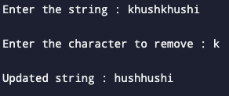
Theoretical Principle: We will use the basic knowledge of string functions and loops to print the desired output.

Practical No:6(b)
Aim: Read a name from the keyboard and find out how many times the same character (case in sensitive) is repeated using string manipulation functions in C language.
Methodology Followed:
#include <stdio.h>
#include <string.h>

int main()
{
char name[100], ch;
printf("Enter your string : ");
gets(name);
for (int k = 0; name[k] != '\0'; k++)
{
name[k] = tolower(name[k]);
}
for(char i='a';i<='z';i++)
{
int count = 0;
for(int j=0; j<strlen(name); j++){
if(name[j]==i){
count++;
}
}
if(count>1)
{
printf("\n%c is %d time", i, count);
}
}
}

Input/Output:
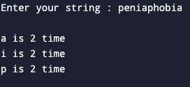
Theoretical Principle: We used string manipulation, character counting,looping constructs and conditional statements.

Conclusion: Here we learnt to use string manipulation functions.

